Experiment:12 Date:1/08/2027

To Implement the Alpha-Beta Pruning Algorithm

Aim
To develop a Python program to implement the Alpha-Beta Pruning Algorithm for finding the optimal move in a game tree by reducing the number of nodes evaluated during the Minimax search.

Algorithm (Alpha-Beta Pruning)
- Read the number of leaf nodes.
- Read the utility values of the leaf nodes.
- Initialize alpha = -∞ and beta = +∞.
- Traverse the game tree using the Minimax approach.
- Update the alpha and beta values.
- Prune the branches that cannot improve the final result.
- Display the optimal utility value.
Program:
import math
def minimax(depth, node, maximizing, values, alpha, beta):
if depth == 3:
return values[node]
if maximizing:
best = -math.inf
for i in range(2):
val = minimax(depth+1, node*2+i, False, values, alpha, beta)
best = max(best, val)
alpha = max(alpha, best)

if beta <= alpha:
break

return best

else:
best = math.inf
for i in range(2):
val = minimax(depth+1, node*2+i, True, values, alpha, beta)
best = min(best, val)
beta = min(beta, best)
if beta <= alpha:
break
return best

print("Enter 8 Utility Values")
values = []
for i in range(8):
values.append(int(input()))
result = minimax(0, 0, True, values, -math.inf, math.inf)
print("\nUtility Values:", values)
print("\nOptimal Value =", result)
Output:
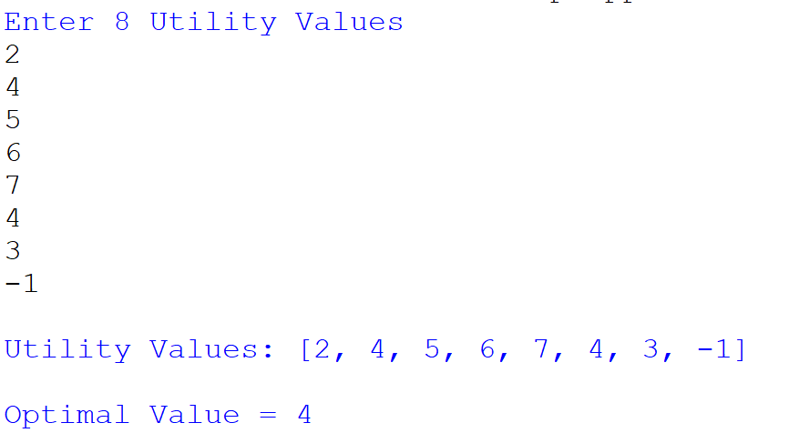

Result
Thus, the Alpha-Beta Pruning Algorithm was implemented successfully, and the optimal utility value was obtained by pruning unnecessary branches during the search process.

